110. Balanced Binary Tree
Easy

Given a binary tree, determine if it is
height-balanced
.

Example 1:
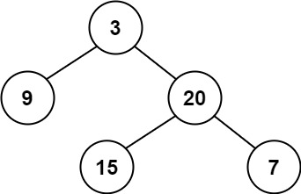
Input: root = [3,9,20,null,null,15,7]
Output: true
Example 2:
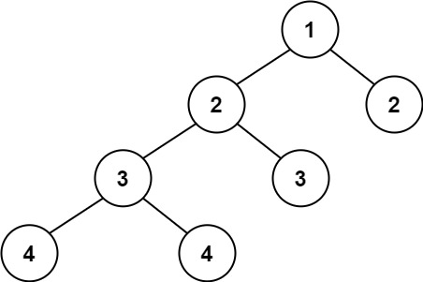
Input: root = [1,2,2,3,3,null,null,4,4]
Output: false
Example 3:
Input: root = []
Output: true

Constraints:
- The number of nodes in the tree is in the range [0, 5000].
- -104 <= Node.val <= 104

